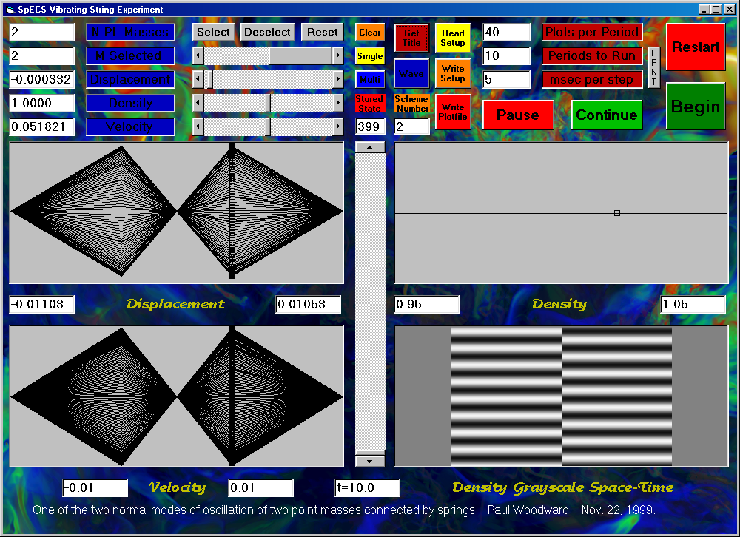
The screen image above shows the result of performing the first vibrating string experiment, using the setup file users-guide-setup-1.txt provided with the instructor’s package. A listing of this setup file follows:

"NDifferenceScheme", 2
"NGridCells", 2
"WaveSpeed0", 1
"CourantNumber", .5
"YMax", .0105
"YMin", -.0105
"RhoMax", 1.05
"RhoMin", .95
"VYMax", .01
"VYMin", -.01
"Periods", 10
"NPlotsPerPeriod", 40
"NSelected", 2
""
"MSelected", "Y", "Rho", "VY"
0, 0, 1, 0
1, .01, 1, 0
2, -.01, 1, 0
3, 0, 1, 0

This first experiment illustrates one of the two normal modes of vibration for two point masses, each with mass 1/3, joined to each other and to fixed walls by massless springs, each with length 1/3. The tension in the springs is unity. The motion of the point masses is followed for about 8 vibration periods.
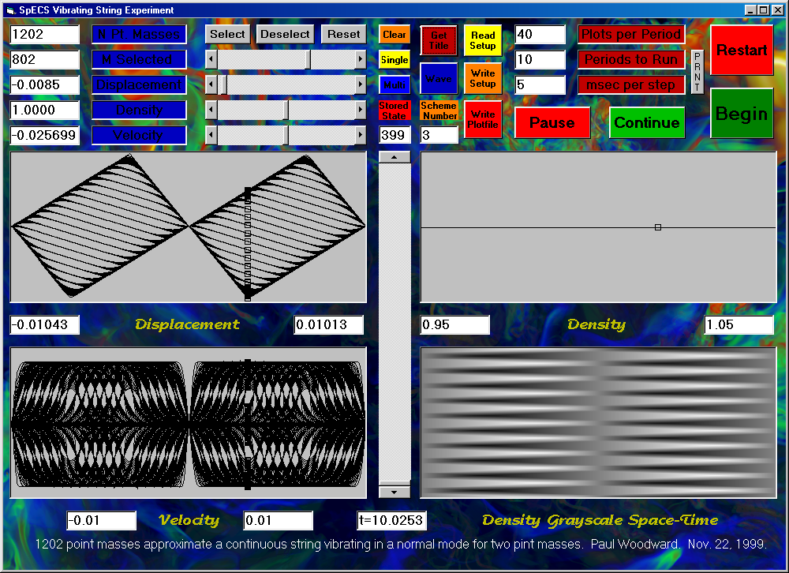
The screen image above shows the end of an experiment in which the same initial condition is applied, but to a string, of length unity, consisting of 1202 point masses, with unit average mass per unit length. Ten periods of this vibration are now shown in the same total elapsed time. Because the total mass of this string is 1202/1203, as compared to a total mass of only 2/3 for the earlier system of just 2 point masses, the period of the vibration is altered. The program measures time in units of the vibration period for this fundamental mode of the continuous string. Both of these oscillations are standing waves, as is evident from the space-time plots in the bottom right of each screen display. Traveling wave behavior is obtained by clicking on the “Wave” button before launching this experiment. The result of this is shown in the screen image below.
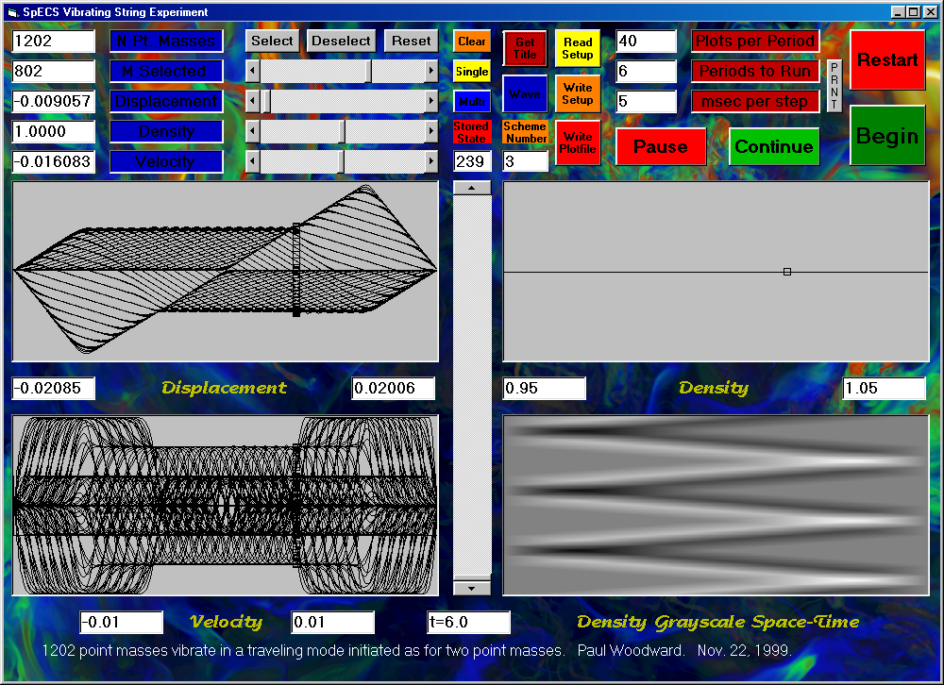
The setup file for the standing-wave version of this experiment, from which this traveling wave example was derived, is as follows:

"NDifferenceScheme", 3
"NGridCells", 1202
"WaveSpeed0", 1
"CourantNumber", .5
"YMax", .0105
"YMin", -.0105
"RhoMax", 1.05
"RhoMin", .95
"VYMax", .01
"VYMin", -.01
"Periods", 10
"NPlotsPerPeriod", 40
"NSelected", 2
""
"MSelected", "Y", "Rho", "VY"
0, 0, 1, 0
401, .01, 1, 0
802, -.01, 1, 0
1203, 0, 1, 0
The dissipative difference scheme number 3 was used in these experiments in order to keep the velocity distributions well behaved. If we use instead scheme 4, we get slight ringing at the sudden velocity jumps, but the sharp corners in the displacement, resulting from plucking the string, are better preserved. The result of using scheme 4 in the traveling wave experiment is shown below.
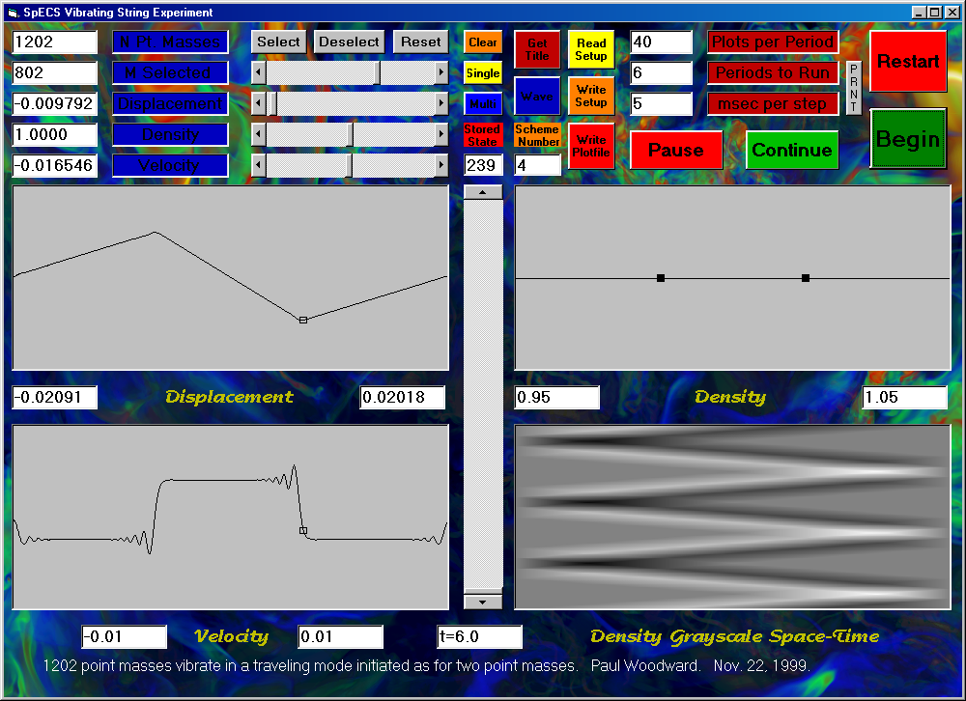
This sort of sharp representation of the string behavior can be obtained with the more dissipative scheme 3 by using many more point masses, say 3602. The short wavelength oscillations in the velocity behind the propagating velocity jumps is behavior possible for point masses connected by springs, but it is not possible for, say, a guitar string. The result of using 3602 point masses with scheme 3 for this problem is shown below.
Even using as many as 3602 point masses, we still get visible rounding of the initially sharp corners on our waveform. Although we might try using, say, 4802 point masses, the program enforces a limit of 5001, and that really ought to be enough. As we go to more and more point masses, and these corners grow sharper and sharper, our system should approach the behavior of a truly continuous string. However, we know from experience that real strings, like violin strings, for example, cannot be bent arbitrarily sharply. So clearly our experiment with the idealized point masses and massless springs is approaching some limit for an unrealistically idealized vibrating string, a string with elasticity to make it vibrate but with no stiffness to resist sharp bending.
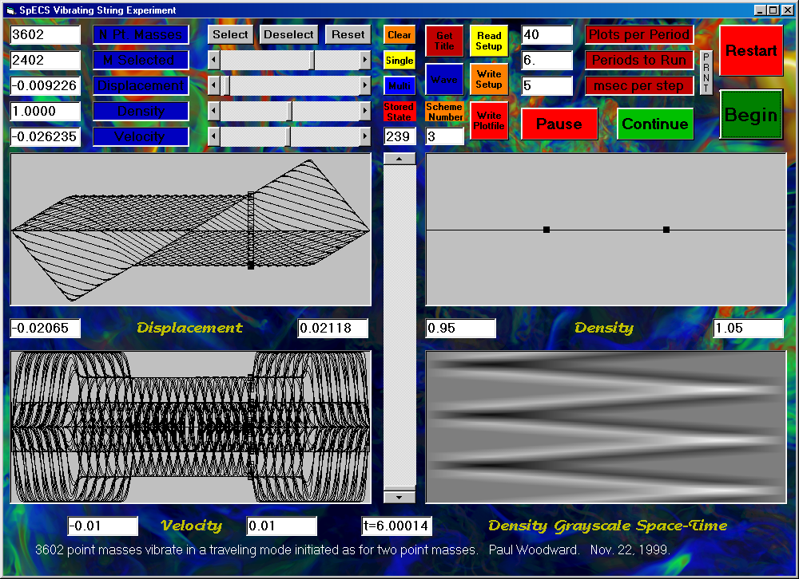
In these experiments with large numbers of point masses, the standing wave behavior can be understood as resulting from the superposition of two traveling waves, each moving at the same speed in opposite directions and each having half the amplitude of the initial transverse displacement distribution. To see that this is indeed how these vibrations occur, we can set up a plucked waveform of the same initial shape, but this time localized within the center third of the string. Then we can observe the component traveling waves as they emerge, going in opposite directions. We will first take our original standing wave experiment, using 1202 point masses, and we will add 1202 point masses with zero initial displacement on each side. The program will force this new, augmented string to have unit length, as before. This means that at a time of 1/6 we should expect to observe both component waves isolated, having just separated from each other. At time 1/3, each should just be hitting one of the fixed walls. At time unity, both should be exactly superposed again, because each component wave was reflected at a wall. The following setup file can be used to run this experiment to time 2:

"NDifferenceScheme", 3
"NGridCells", 3608
"WaveSpeed0", 1
"CourantNumber", .5
"YMax", .0105
"YMin", -.0105
"RhoMax", 1.05
"RhoMin", .95
"VYMax", .01
"VYMin", -.01
"Periods", 2
"NPlotsPerPeriod", 100
"NSelected", 4
""
"MSelected", "Y", "Rho", "VY"
0, 0, 1, 0
1203, 0, 1, 0
1604, .01, 1, 0
2005, -.01, 1, 0
2406, 0, 1, 0
3609, 0, 1, 0
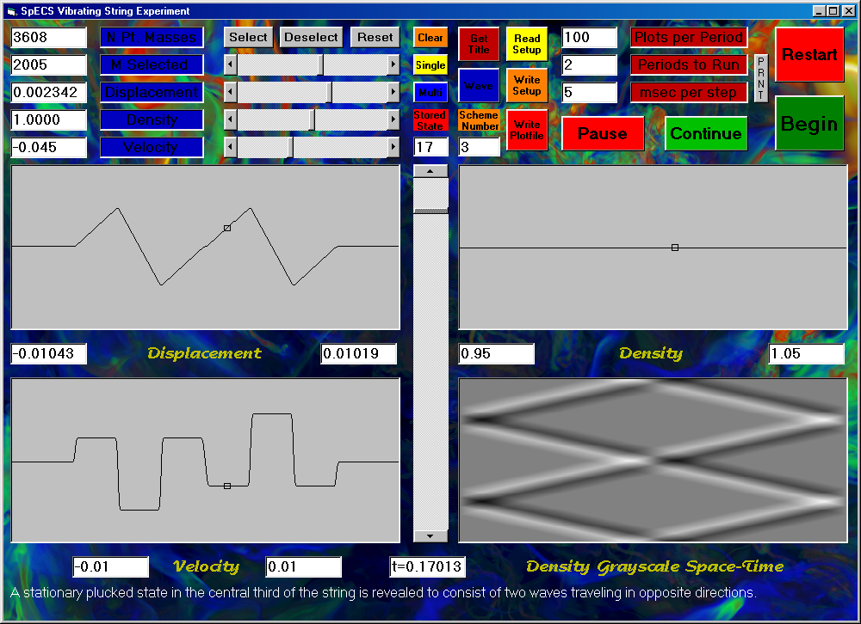
Above, the screen is shown after the experiment has run all the way to time 2 and has generated its space-time plot at the lower right in the screen image. The waveform is shown just after time 1/6. Two identical waves, propagating in opposite directions have just emerged from the initial stationary structure created by plucking the string at the 4 selected points listed in the setup file above. At time 1/3, these two waves are just reaching the walls. Their shapes are unchanged. The waveform at this time is shown below.
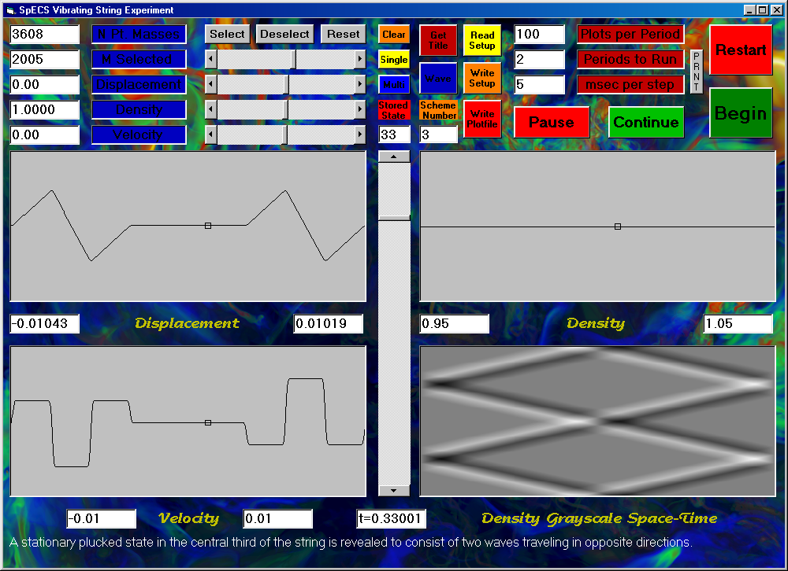
Upon reflection at each wall, the two waves emerge looking precisely as they do at time 1/3, but now traveling toward rather than away from each other. At time 1 they are exactly superposed once again, assuming precisely the same transverse displacements and velocities as at the beginning. As each wave reflects at its wall, its amplitude flips sign. Thus, for example, the wave striking the right-hand wall has a leading section of negative amplitude and a trailing section of positive amplitude. After reflection, the leading section is positive and the trailing one is negative, resulting in a wave of precisely the same shape, but propagating in the opposite direction. This sign flip upon wave reflection is most noticeable when the incident wave has an unsymmetrical shape, such as a waveform with only positive transverse displacements, which upon reflection has only negative displacements. This behavior can be observed in the following experiment.
In the next experiment, generated from the setup file users-guide-setup-2.txt, an isolated rightward traveling triangular wave impinges on a sudden change in string density from 1 to 16. This sudden change in string density (mass per unit length) is located at the middle of the string. A listing of the setup file follows:

"NDifferenceScheme", 3
"NGridCells", 4001
"WaveSpeed0", 1
"CourantNumber", .5
"YMax", .0105
"YMin", -.0105
"RhoMax", 16.721
"RhoMin", .95
"VYMax", .110330125000003
"VYMin", -.1055525
"Periods", 6
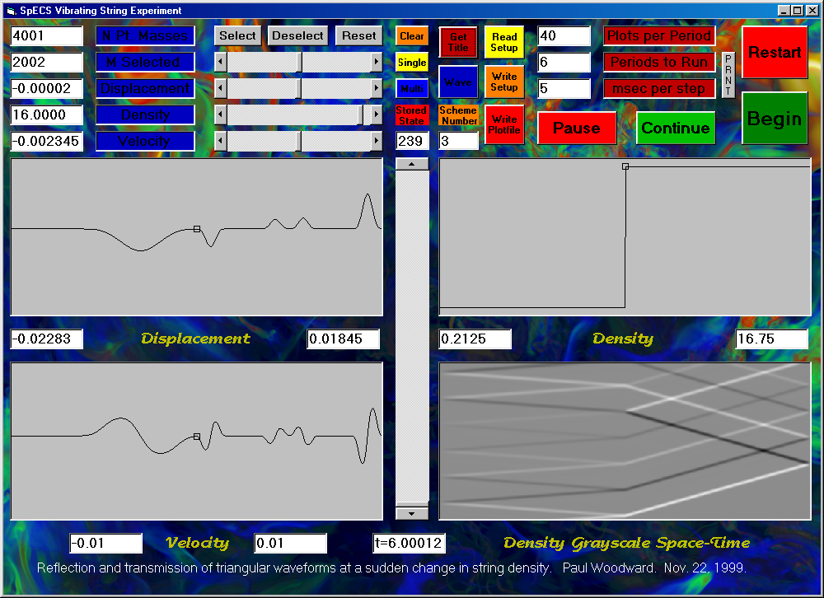
"NPlotsPerPeriod", 40
"NSelected", 17
""
"MSelected", "Y", "Rho", "VY"
0, 0, 1, 0
1, 0, 1, 0
1000, 0, 1, 0
1001, 0, 1, 0
1002, .000025, 1, 0
1400, .009975, 1, 0
1401, .01, 1, 0
1402, .009975, 1, 0
1800, .000025, 1, 0
1801, 0, 1, 0
1802, 0, 1, 0
2000, 0, 1, 0
2001, 0, 1, 0
2002, 0, 16, 0
2500, 0, 15.97, 0
2501, 0, 16, 0
2502, 0, 16, 0
4001, 0, 16, 0
4002, 0, 16, 0
The screen is shown at the end of this experiment. A number of reflection and transmission events for triangular waveforms at the sudden change in string density are recorded in the space-time diagram at the lower right of the screen image. The wave bouncing back and forth between the left-hand wall and the site of the sudden string density change becomes progressively weaker as it transmits more and more of its energy into the denser section of the string. Note that on each reflection at the density jump the amplitude of this wave preserves its sign and the amplitude of the wave transmitted into the denser section of the string is greater than that of the incident wave. The wave in the denser region propagates 4 times more slowly than that in the lighter region. It travels across this region and back while the wave in the left-hand region bounces precisely 4 times back and forth, as is clear from the space-time diagram. Thus we may observe that for equal string tension, the wave propagation speed varies as the square root of the string density. Also note the flip in the sign of the amplitude of the wave approaching the density jump from the right, within the denser string segment, as it reflects off of this sudden jump.
In the next experiment, we will attempt to reduce the amplitude of reflected waves in the previous experiment by a technique referred to in electronics as “impedance matching.” This same technique is also used to reduce the amplitude of reflected waves in acoustics. Audiophiles will understand that the exponential horn on a mid-range speaker, or tweeter, or, in fact, on the horn of a trumpet is an example of impedance matching. The shape of these horns makes the width of the duct in which the column of air is vibrating increase exponentially until, at the mouth of the horn, it becomes effectively infinite. This exponentially increasing duct (or pipe) width minimizes the intensity of sound waves that are reflected back into the horn. In our next experiment, we will perform just the same trick. We will, at least approximately, increase the density of our string exponentially, beginning with the value 1 and ending with the value 16. To do this, we will double the density of the string every 100 point masses, using a linear increase over the 100 point masses to accomplish this doubling. The setup file for this new experiment, users-guide-setup-2a.txt, is as follows:

"NDifferenceScheme", 3
"NGridCells", 4001
"WaveSpeed0", 1
"CourantNumber", .5
"YMax", 1.00537500344217E-02
"YMin", -5.02687501721084E-04
"RhoMax", 16.75
"RhoMin", .2125
"VYMax", .110305127575994
"VYMin", -.105052502453327
"Periods", 6
"NPlotsPerPeriod", 40
"NSelected", 18
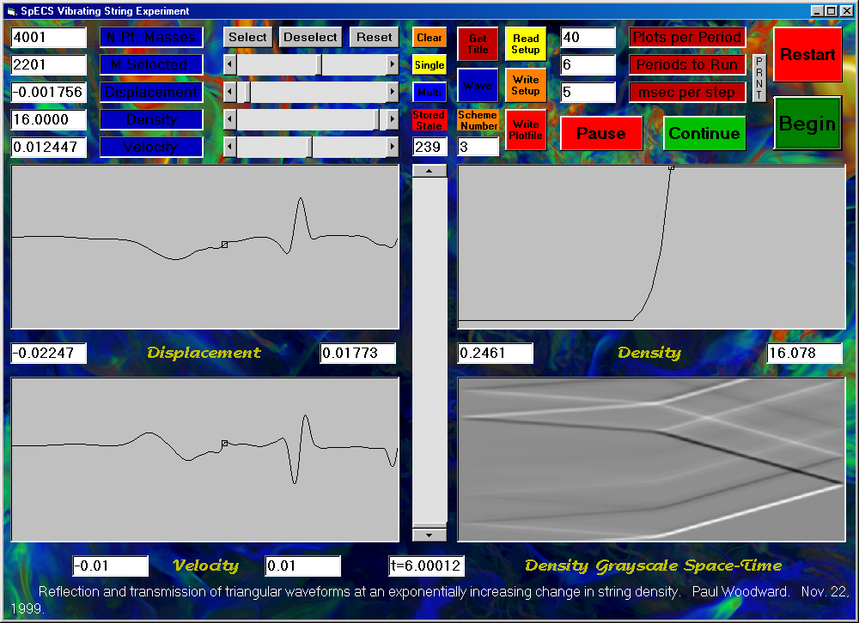
""
"MSelected", "Y", "Rho", "VY"
0, 0, 1, 0
1, 0, 1, 0
1000, 0, 1, 0
1001, 0, 1, 0
1002, .000025, 1, 0
1400, .009975, 1, 0
1401, .01, 1, 0
1402, .009975, 1, 0
1800, .000025, 1, 0
1801, 0, 1, 0
1802, 0, 1, 0
1901, 0, 2, 0
2001, 0, 4, 0
2101, 0, 8, 0
2201, 0, 16, 0
2500, 0, 15.97, 0
2501, 0, 16, 0
2502, 0, 16, 0
4001, 0, 16, 0
4002, 0, 16, 0
Clearly, the transmission properties of this approximately exponential section of increasing string density are dramatically different from those of the sudden density jump of the previous experiment. We can improve our “impedance match” still further by spreading the exponential density increase out over a still wider region. It is the width of the region over which the density changes a lot (such as by a factor of 2) as compared to the signal wavelength that turns out to matter here. The result of such an improved experiment is shown below. It is somewhat disappointing.
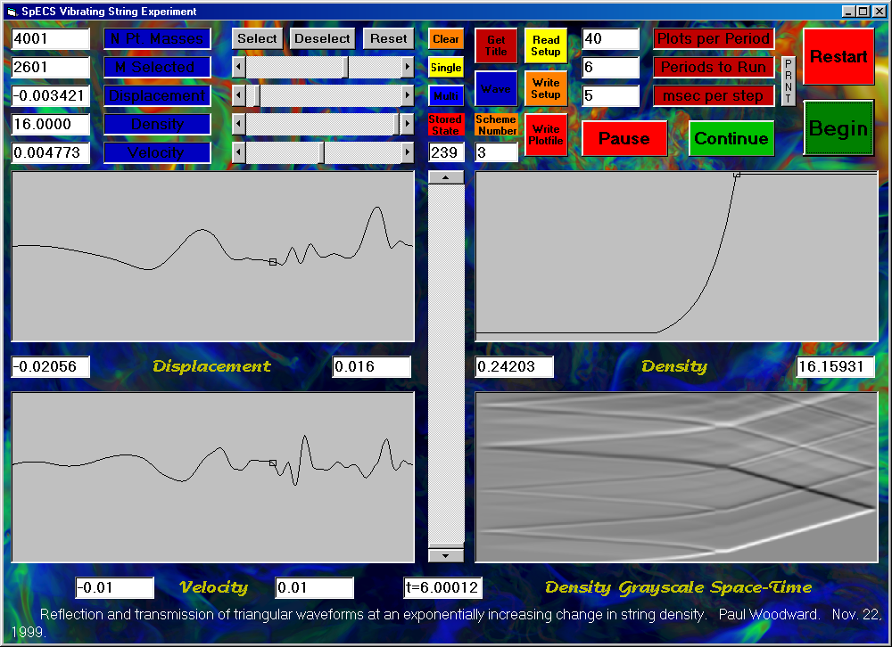
The setup file, users-guide-setup-2b.txt, for this experiment is as follows:

"NDifferenceScheme", 3
"NGridCells", 4001
"WaveSpeed0", 1
"CourantNumber", .5
"YMax", 1.00537500344217E-02
"YMin", -5.02687501721084E-04
"RhoMax", 16.0779996395111
"RhoMin", .246100018024445
"VYMax", .110305127575994
"VYMin", -.105052502453327
"Periods", 6
"NPlotsPerPeriod", 40
"NSelected", 19
""
"MSelected", "Y", "Rho", "VY"
0, 0, 1, 0
1, 0, 1, 0
1000, 0, 1, 0
1001, 0, 1, 0
1002, .000025, 1, 0
1400, .009975, 1, 0
1401, .01, 1, 0
1402, .009975, 1, 0
1800, .000025, 1, 0
1801, 0, 1, 0
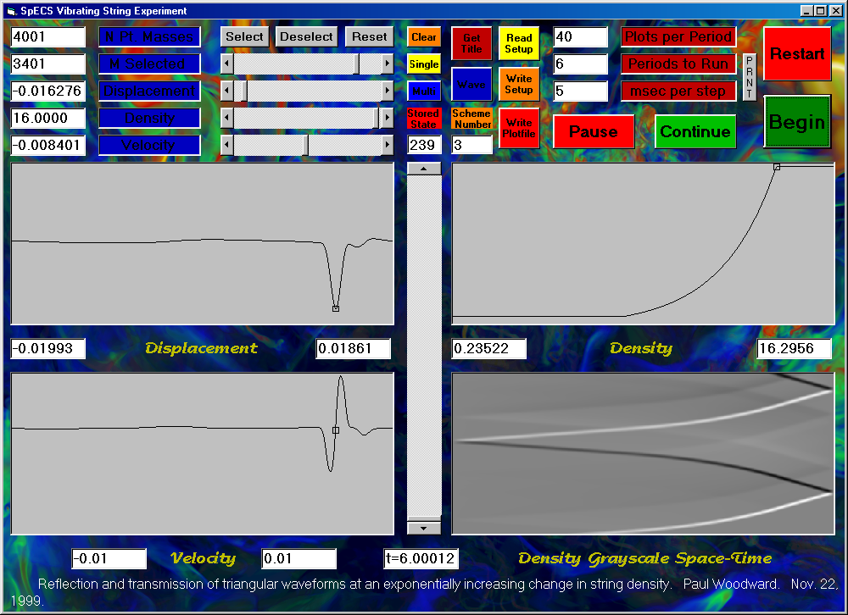
1802, 0, 1, 0
1901, 0, 1.414, 0
2001, 0, 2, 0
2101, 0, 2.828, 0
2201, 0, 4, 0
2301, 0, 5.656, 0
2401, 0, 8, 0
2501, 0, 11.312, 0
2601, 0, 16, 0
4001, 0, 16, 0
4002, 0, 16, 0
In the experiment whose result is shown above, we have made the exponential increase in string density from 1 to 16 take twice the distance as in the previous trial. Now, at last, we have achieved nearly perfect wave transmission, with negligible reflection. At last we have made the string density change significantly over distances that are rather large compared to the signal width, and the result is nearly minimal wave reflection. The setup file for this final experiment, users-guide-setup-2c.txt, is as follows:

"NDifferenceScheme", 3
"NGridCells", 4001
"WaveSpeed0", 1
"CourantNumber", .5
"YMax", 1.00537500344217E-02
"YMin", -5.02687501721084E-04
"RhoMax", 16.159311914444
"RhoMin", 0
"VYMax", .110305127575994
"VYMin", -.105052502453327
"Periods", 6
"NPlotsPerPeriod", 40
"NSelected", 27
""
"MSelected", "Y", "Rho", "VY"
0, 0, 1, 0
1, 0, 1, 0
1000, 0, 1, 0
1001, 0, 1, 0
1002, .000025, 1, 0
1400, .009975, 1, 0
1401, .01, 1, 0
1402, .009975, 1, 0
1800, .000025, 1, 0
1801, 0, 1, 0
1802, 0, 1, 0
1901, 0, 1.18921, 0
2001, 0, 1.4142, 0
2101, 0, 1.681793, 0
2201, 0, 2, 0
2301, 0, 2.378414, 0
2401, 0, 2.82843, 0
2501, 0, 3.3636, 0
2601, 0, 4, 0
2701, 0, 4.75683, 0
2801, 0, 5.656854, 0
2901, 0, 6.7272, 0
3001, 0, 8, 0
3101, 0, 9.51366, 0
3201, 0, 11.3137, 0
3301, 0, 13.45434, 0
3401, 0, 16, 0
4001, 0, 16, 0
4002, 0, 16, 0
Students are encouraged to play around with this vibrating string program. It is interesting to try running the above experiments using difference scheme 2. This scheme gives a closer approximation to the behavior of dense masses connected by light springs than do the dissipative schemes numbered 3 and 4. However, scheme 3 gives the most robust performance and corresponds most closely to the behavior of real strings (or wires) that have some degree of stiffness. It is also fascinating to observe the different vibration modes for strings plucked in their middles and plucked, as in a harpsichord, near one end. Enjoy (and learn)!

